**e-Portfolio Update: Data Collection**

**Topic:** An Investigation into the gender pay gap in the technology sector in South Africa.

Method: Explanatory Sequential Mixed-Model

* Quantitative Study
  + Data Collection – Surveys, Likert Scale Closed-ended questions, Pilot Survey.
  + Data Analysis – Descriptive analysis and inferential test
* Qualitative Study
  + Data Collection - Semi-structured interviews
  + Data Analysis: Thematic analysis and coding.

Quantitative Data Collection and Analysis

* Design and conduct surveys for students on the use of technology, its benefits and drawbacks, and their preferences. Utilize Likert scale and closed-end questions. Conduct a pilot survey to validate the survey tool and evaluate its reliability. Depending on the results, survey items may require revision.
* Process data using descriptive analysis and inferential test to identify, describe, summarise, and analyse student responses, as well as to derive patterns and correlations.

Qualitative Data Collection and Analysis

* Prepare semi-structured interview guides. Tailor questions to gather in-depth insights into students participants’ learning experiences and attitudes regarding modern technology integration in their higher education institutions.
* Conduct interviews and record responses and transcribing them for analysis.
* Carry out coding and thematic analysis are used to break down, compare, comprehend, and classify data in order to identify common themes.

Interpretation and Reporting

* Integrate the results of surveys and interviews to create a comprehensive report and use triangulation techniques to verify and confirm data from a variety of sources.
* Compare data across different educational institutions, fields, and participant populations to recognize similarities and disparities.
* Prepare a research report and provide practical recommendations to educators, institutes, and policy makers based on the findings.

Figure 1. Below depicts the development process for an explanatory sequential mixed-method research design, it captures the phase, procedures, and product output.

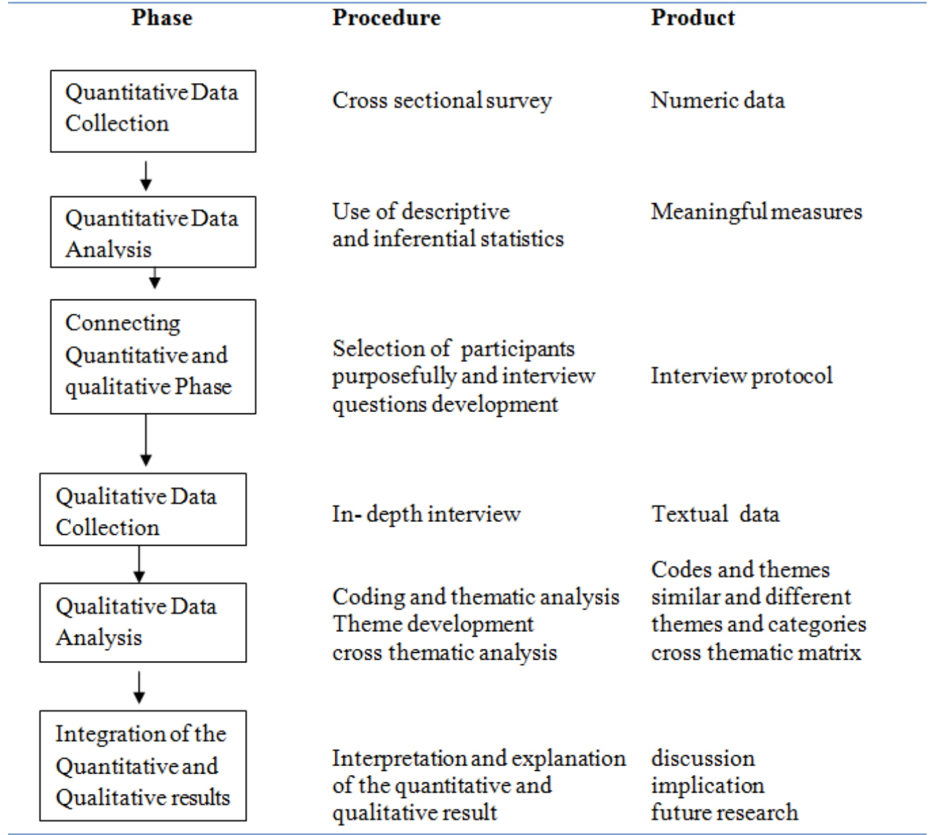

Figure 6.1. Explanatory Sequential Research Design (Subedi, 2016).

The research questions for the study are as follows:

* How does modern technology in higher education influence student engagement, motivation, and academic performance? – **Quantitative – Survey.**
* What strategies and teaching methods are most effective in incorporating modern technologies such as gamification, simulation, and online learning platforms into higher education? – **Quantitative – Survey.**
* What are the student perceptions and attitudes towards the integration of modern technology in their learning experiences? **– Qualitative – Interviews.**
* What are the challenges faced by students and their learning experiences pertaining to the incorporation of modern technology? **– Qualitative – Interviews.**

**References**

Subedi, D. (2016) Explanatory Sequential Mixed Method Design as the Third Research Community of Knowledge Claim. *American Journal of Educational Research* (4)7:570-577. Available from: <https://www.researchgate.net/publication/316546967_Explanatory_Sequential_Mixed_Method_Design_as_the_Third_Research_Community_of_Knowledge_Claim> [Accessed 19 October 2023].